AME 308 Project | S20 DRONE
Members: Bobby Rogers, Gabriella Galderisi, Guilherme Jardim, Katie Larson, Tanaya Maharaj
Introduction and Goals
The S20 drone is a lightweight helicopter UAV designed for aerial photography. Its design incorporates a central drone body, four rotors with propellers, protective propeller guards, a battery compartment, landing gear, and a camera mount. The goal of this project was to reproduce the S20 drone in NX with professional CAD models, assemblies, and engineering documentation, enabling accurate manufacturing and assembly.
Key goals of this project included:
- Accurate reproduction of all drone parts in NX, including fully defined sketches, materials, and colors.
- Development of a professional assembly with exploded views and BOM.
- FEA analysis of the drone body to ensure it withstands realistic loads without plastic deformation.
- Motion analysis of propellers and landing gear to validate functionality during operation.

CAD Modeling:
Part | Material Used | Key Modeling Features Used
Drone Body | ABS Plastic | Extrude, Trim Body, Datum Planes, Unite
Propeller | ABS Plastic | Through Curves, Datum Plane
Propeller Guard | ABS Plastic | Extrude, Unite, Datum Plane, Offset Curve
Front Legs | ABS Plastic* | Extrudes, Chamfers, Pattern
Back Legs | ABS Plastic* | Extrudes, Chamfers, Pattern
Battery Housing | ABS Plastic* | Extrude, Trim Body, Datum Planes, Pattern Feature
Connectors | ABS Plastic | Extrude
* These parts aren’t entirely made of ABS, but were assumed to be primarily ABS.

Drone Body:
The drone body was modeled in NX using a diverse set of features to manipulate various extrusions and sketches. The main form was created from primary sketches of the top, side, and bottom profiles and extrusions of those profiles. These were rough line sketches with a spline used to get the shape of the top. Then, the body was refined using datum planes, trim, and split operations to get shapes and cuts at the desired angles. The mirror feature was used to keep the symmetry of the real drone. The holes and ridges on the bottom of the drone (the vents) were created with sketches and extrusions and copied using the pattern feature. The feet of the drone were created using two sketches and then a geometry wrap. The unite feature was used to merge the many separate solid bodies created during the design process. We later created the battery and camera and extruded out the parts of the body where they would go. This whole process allowed us to accurately match the drone’s shape while maintaining clean parametric organization. To get the ridges on the top and the blue LED lights towards the back of the drone, the offset feature was used. As a final step, blends and chamfers were added to make the body seem less blocky.

Drone Battery Housing:
The battery thumbprint on the top was created using a sketch of an ellipse and extruding, which subtracted from the main body. Then, edge blends were used to create the rounded thumbprint look. The hook was made by subtracting from the body using the extrude feature and then sketching out the hook to be slightly shorter (so it could move up and down when pressed by the button on the bottom). The hook was created using a few extruded sketches then united with itself then the button on the bottom. The vents on the side are patterned lines with arcs extruded to subtract from the body.
Camera:
The general sizing of the camera was found when creating the body. From there, the camera was made in a separate part file. It was primarily composed of extrusions. The offset sketch feature was used to get the stepping sections in the center of the camera. To get the attachment feature, the circles were extruded perpendicular to the camera to allow for the intended 90-degree swivel.
Back Legs:
The propeller attachment housing was approached first. A mix of circle extrusions and revolutions was used. A circular pattern was used to get the cutouts in the top. To get the beam portion, the pentagon shape was extruded from the motor housing. The attachment needed to be at a 60° angle, so the sketch was created on the XY plane and extruded up. To get the left version of the leg, this sketch was flipped.
Front Legs:
These parts were created in a similar way to the back legs. The main addition was adding the stilts onto them using a through curve.
Propeller Mechanism:
The propellers were observed to consist of two blades with a center connector. First, the blades were created by creating a sketch of the airfoil initially, then the airfoil at its largest point, and its smallest point, each on appropriately offset datum planes. Using the through curve tool, this was made into a wing. Then a connector with a cylindrical hole and a rounded outer end was added to the blade, allowing it to integrate with the mechanism. The connector was created with three cylinders, one on each side for each blade to connect, then a center cylinder for the mechanism to connect to each leg.
Propeller Guard:
The round part of the guard was initially created using an arc and an offset curve, then extruded. Then, symmetric rectangles were drawn on the bottom face of this body and extruded along a vector so they angled down properly. Then the bottom arm was made using a rectangular sketch with offset circles at the end to create the snap closure mechanism.
Engineering Drawings
All components were drafted with full dimensions, tolerances, and GD&T to accurately define critical geometry. EX: Drone Body
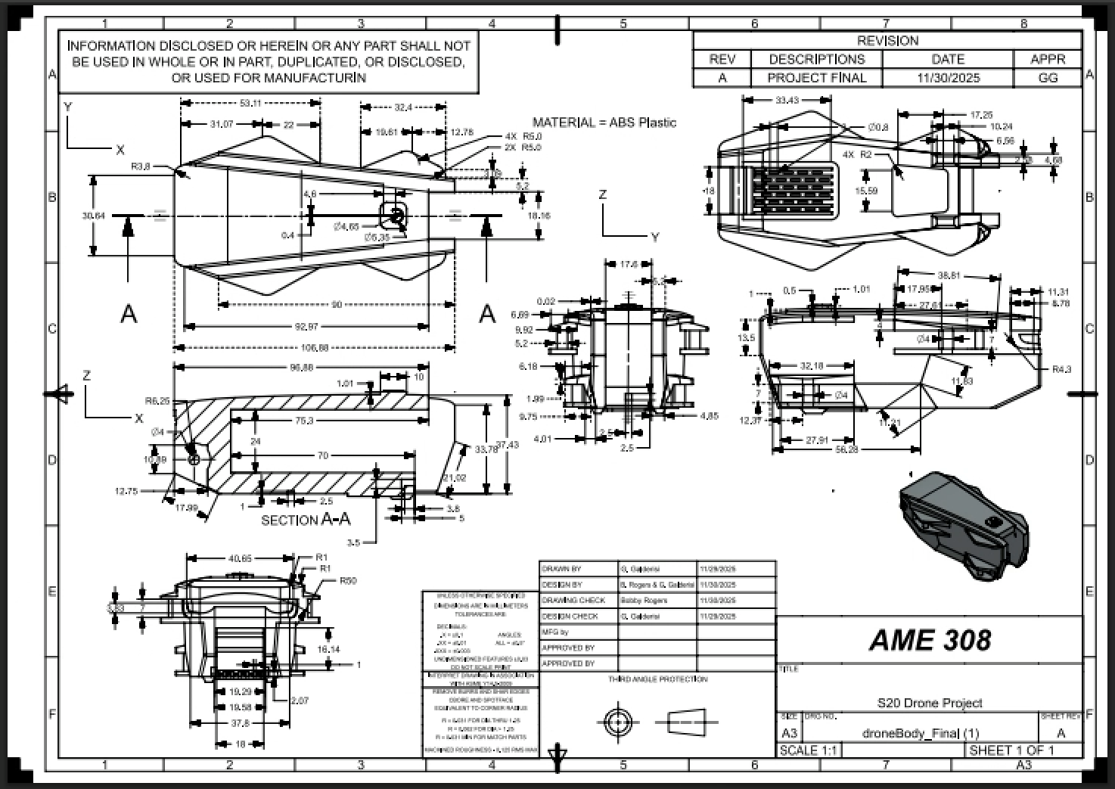
Assembly + BOM
Below is the Bill of Materials and the completed assembly. The assembly has a center of mass of (15.87, -25.44, -14.74) mm when the origin is the front midpoint of the drone body. The final mass was 1.278 kg, and the material of each part was assumed to be primarily ABS.
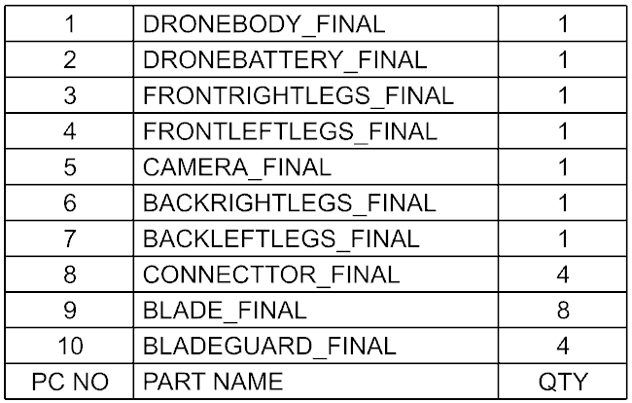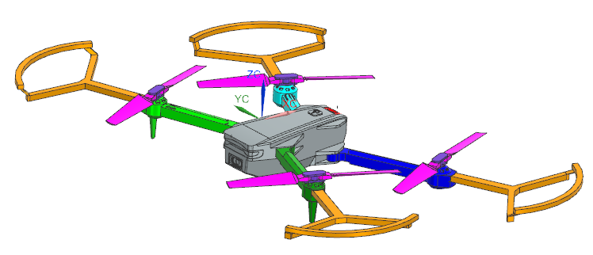
The drone can also be collapsed and have its camera posed.
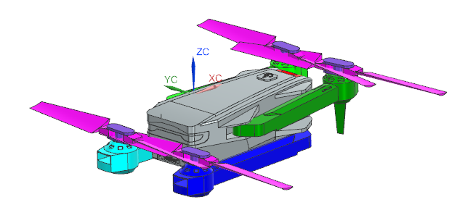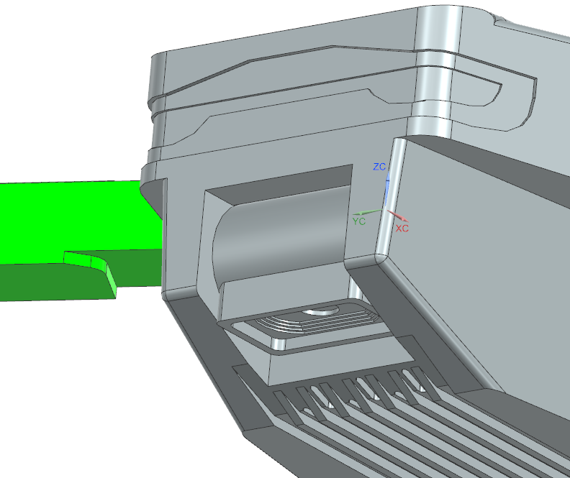
The following figures illustrate the assembly steps and are pulled from drawings in the assembly. (1) Insert the Camera into its holder and slot the battery in. (2) Fasten the legs to the body.
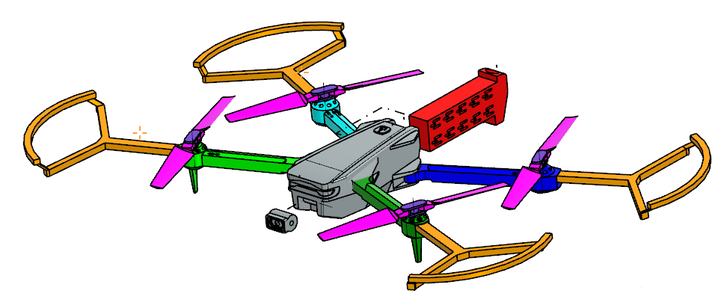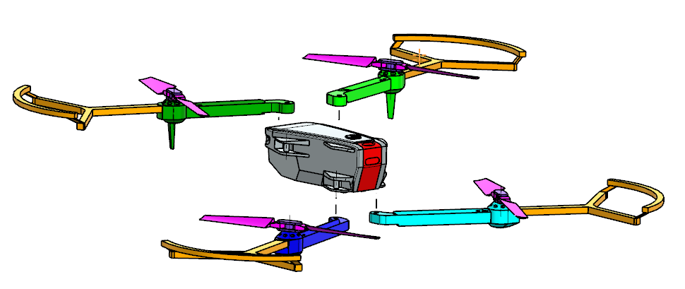

(3) Fasten the propeller blades to the blade connectors. (4) Attach the connectors to the legs.
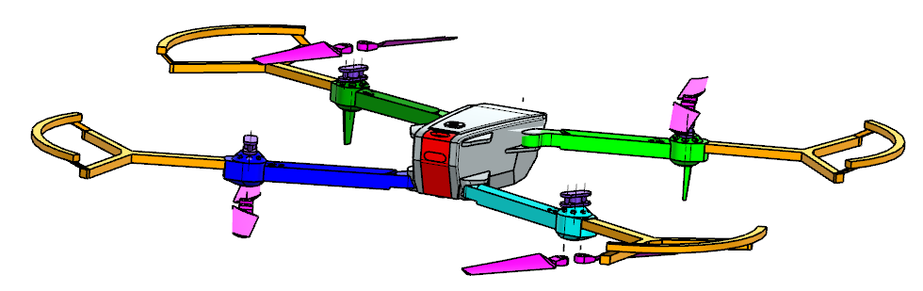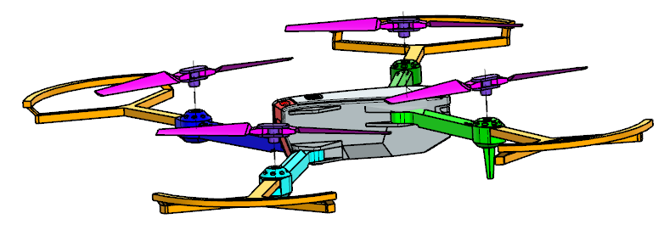
(5) Attach the propeller guards to the slots in the legs.
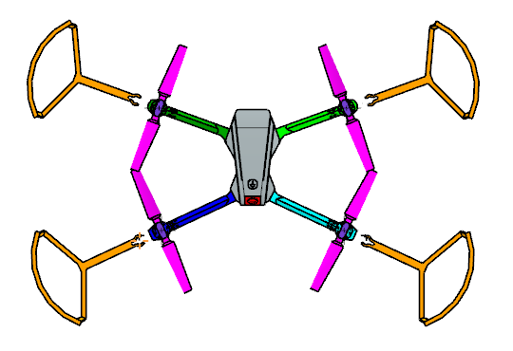
FEA Analysis
The Back Leg was chosen for analysis. The part is a concern because there is a concentrated load far from where the leg is attached to the drone body. In flight, the front legs are structurally identical to the back legs, so only one set of legs needs to be analyzed. The legs also have a design that is specific to this drone, so the design could have flaws and more paths for improvement based on analysis. For this drone, there is an added bend in the legs near the connection point which may cause issues and cause it to have different stress concentrations compared to a traditional beam. Propellers were also of concern, and should be analyzed next. However, they were not prioritized since there is a lot of design heritage with drone propellers. Many drones of similar size to the S20 use nearly identical propeller designs. The propeller blades also have more evenly distributed load and come straight out from their connection points. A linear static simulation was performed.
The BC’s and LC’s of the part are displayed in the figure below. A fixed support was added to the hole that connects the leg to the body (highlighted in blue). No fixed support was added to the top and bottom surfaces of the connected area since there was assumed to be clearance between the flat surfaces and minimal deformation in that area. To simulate the thrust force, a distributed force of 1.074 N was applied to the top of the propeller connection area (highlighted in red). Drones of similar size can support 2-3x their weight, so the max load factor was assumed to be 3 to be conservative. The thrust was assumed to be evenly distributed between the propellers.
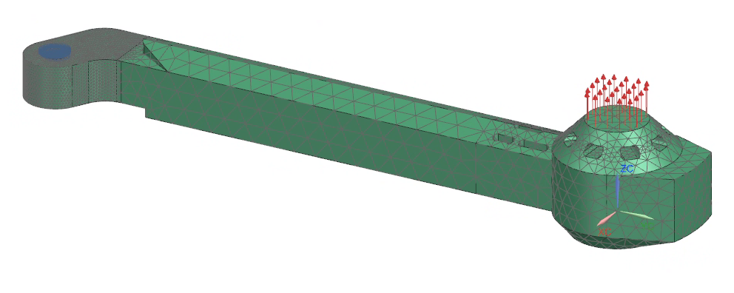
To determine the mesh used in analysis, a mesh density study was performed. General mesh sizings of 3.39 (auto-generated), 2, 1, and 0.5 mm were analyzed. A 0.25 mm mesh sizing was also investigated, but it was not chosen due to heavy computational load and causing a stress singularity to spike. The resulting Max Stress vs. # of Nodes graph is plotted below. The max stress seems to be asymptoting towards 2.5 MPa, and the final stress for the 0.5 mm mesh was 2.465 MPa.
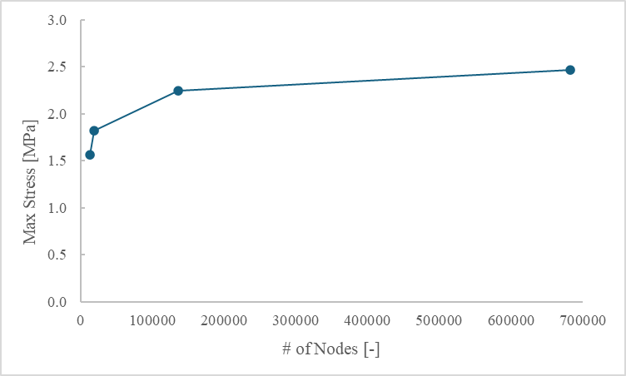
The max stress remained at the top edge of the body connection hole for all meshes. The final mesh was split into three sections: one for the connection point to the body, the plain arm, and the connection point to the propeller. The mesh distribution was 0.5 for the first section, 3.68 for the second section, and 2.72 for the last section. The first section used the mesh density from the mesh study since it had the highest stress concentration. The other two had auto-generated meshes. The two sections were split since the blade connection area had more complicated geometry and therefore should have more complex mesh.
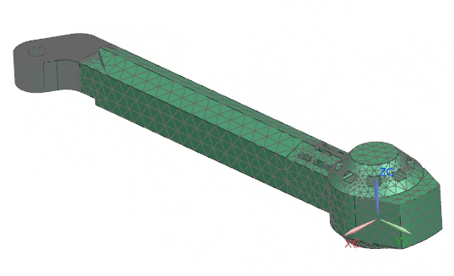
Using this mesh, the max deformation converged to 0.440 mm. This was constant for all meshes used. The max deformation was found at the point furthest from the fixed constraint on the free end. The contour is very similar to what would be expected of a cantilever beam. Nearly zero deformation was found around the fixed constraint, confirming the choice not to place displacement constraints in that area.
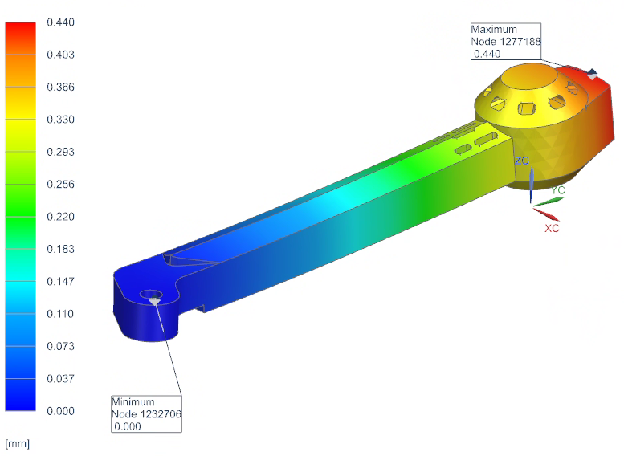
The Max Stress results showed a stress concentration around the fixed constraint and a stress concentration in the bend itself. The max stress (Von-Mises) converged to be 2.391 MPa and was located at the top and bottom of the fixed constraint. This is similar to the results of the beam; the max stress is located near the fixed constraint. However, it does differ significantly. The inside bend had the majority of the stress, whereas the outside of the bend had nearly zero stress. The stress gradient drops off considerably after the bend, and the free end of the leg had nearly no stress at all.
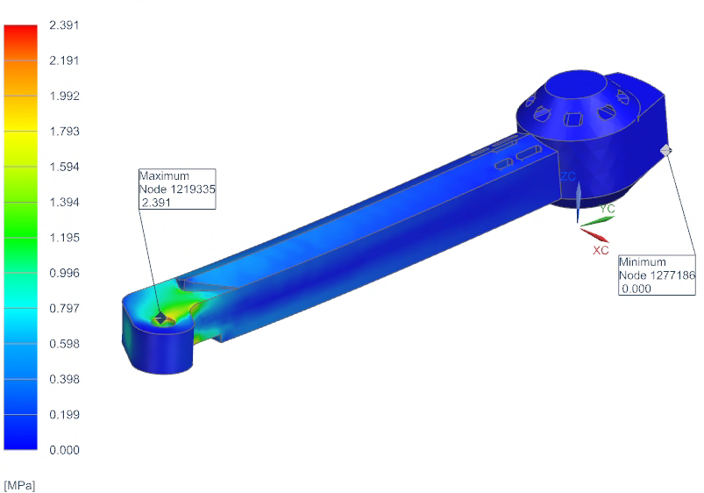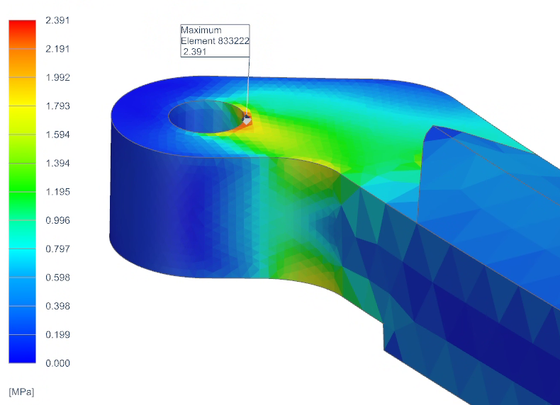
To calculate the Margin of Safety, the part was assumed to have the average tensile yield strength of ABS. Applying a factor of safety of 4, the calculations comes out to
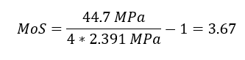
which is an extremely positive result. The part is still in the linear regime since it is well below the yield strength of the material. This also means that the stiffness matrix did not change much. The max displacement was 0.440 mm which is less than 4% of the average height of the length. The assumption of no large displacement holds true.
Because of the large margins, the drone legs are structurally cleared for flight. However, there is also lots of room for optimization. Compared to what we currently have designed, the legs can be hollowed out more and the size and shape can be altered. The official manufacturer has already gone down this route based on the released images. There are cutouts and vent holes further along the leg where there is minimal stress. Also, the legs are likely thinned out slightly to save on mass. The overall displacement of the propeller section is minimal, but its effect of the thrust angle should still be analyzed. Other failure modes like fatigue, should be studied. The drone goes through a lot of loading and unloading cycles, and there is increased stress concentration on the inside bend of the leg. Primary failure modes will instead be impulses due to unexpected drops or collisions. This would explain why propeller guards are included with the drone. This would be hard to analyze, but could be studied through drop testing. With more time for analysis, the propeller blades should also be analyzed.
Motion Simulation and Analysis
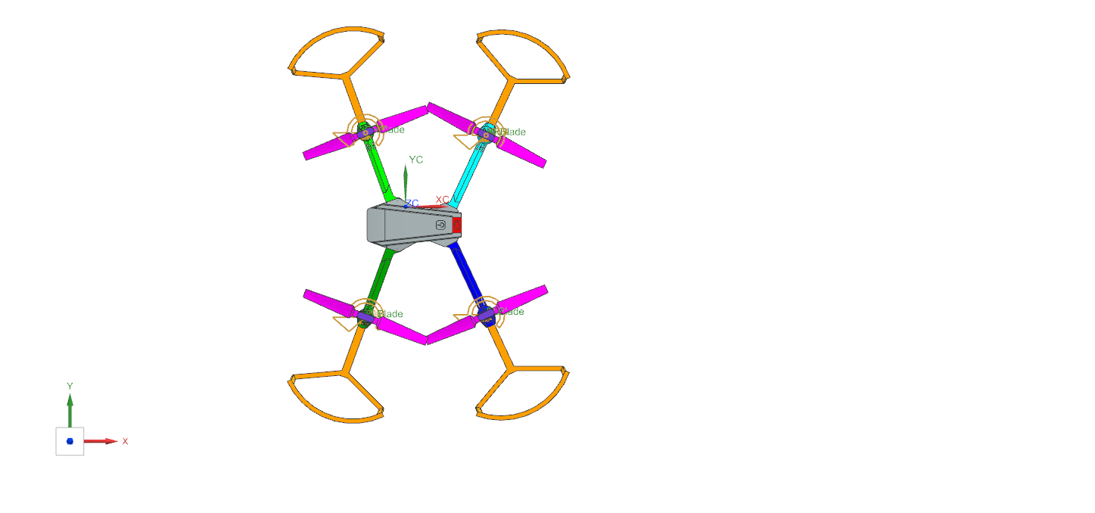
The dynamic simulation used a rigid-body motion model to evaluate the effect of joint friction on the rotational performance of the drone. The two blades and the connector were combined into a single motion body. This was simplified from the actual drone that has a freedom of motion between the connector and the blade but exhibited similar performance to the simplification when tested. The legs, outer body, and protective guards were fully constrained and fixed to the ground, as they do not participate in the rotational motion. The joints were placed on all 4 of the motion bodies for the non-friction The motor was modeled to reach an estimated operating speed of 3000 rpm. It was assumed that the motor reaches maximum speed in 1 second, resulting in a constant angular acceleration of 180,000 rev/min² during the acceleration phase. Two simulation cases were performed. The acceleration-controlled simulation was run for 1 second with a time step of 0.0001 s to accurately capture the dynamic response during rapid spin-up. The velocity-controlled simulation was run for 5 seconds with a 0.001s time step to observe the steady-state behavior after reaching full speed. For the static coefficient was assumed to be 0.3 whilst the kinematic coefficient was 0.25, the friction arm radius of 3 mm was used to represent the effective shaft contact radius.
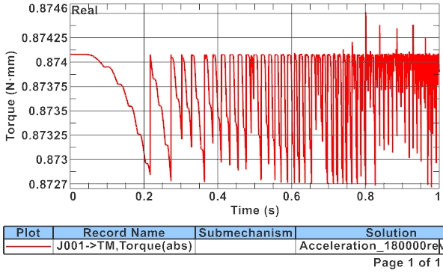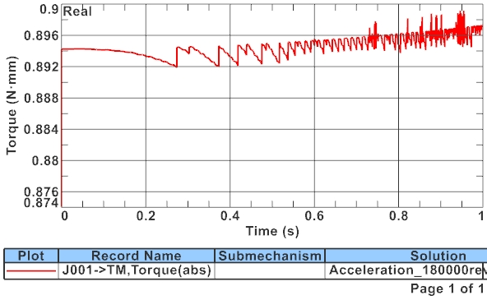
These plots demonstrate differences between the friction and non-friction casesri. Where the torque is consistently high for the friction case.

